**AWS :**

**S3 MFA DELETE**

Step 1 : Login to aws management console and navigate to s3 dashboard.

Step 2: Create s3 bucket with bucket versioning enabled.

Step 3: Now click on bucket and go to its properties.in properties go to “bucket versioning”

Step 4: Edit the bucket versioning and ,you will see that bucket versioning is “enabled” but MFA delete is “disabled”. We want to enable the MFA delete but we can enable it from there ,we can only change the MFA setting through AWS CLI or AWS SDK .Here we will choose Cloudshell to enable the MFA .

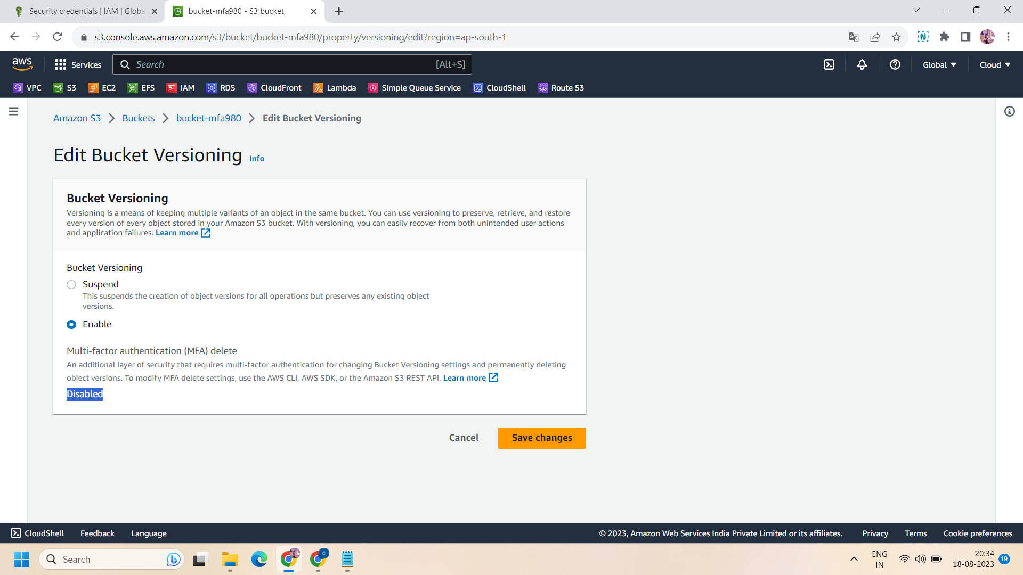

Step 5: To enable it ,make sure you have already set up an MFA. If you have not then go to IAM and setup MFA .But here we already have setup of MFA.

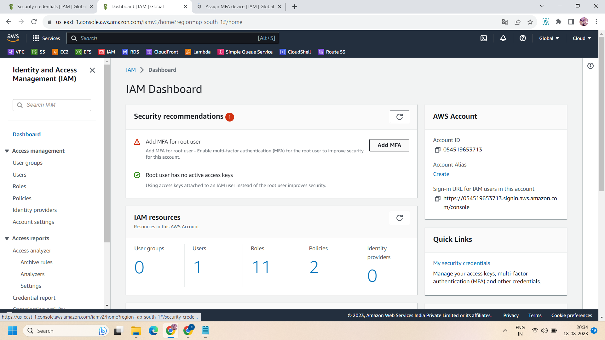

Step 6: After creating MFA settings,click to your account on the right corner and go to your security credentials.In security credentials, go to access policy and click on “create new access policy” and download the key file .

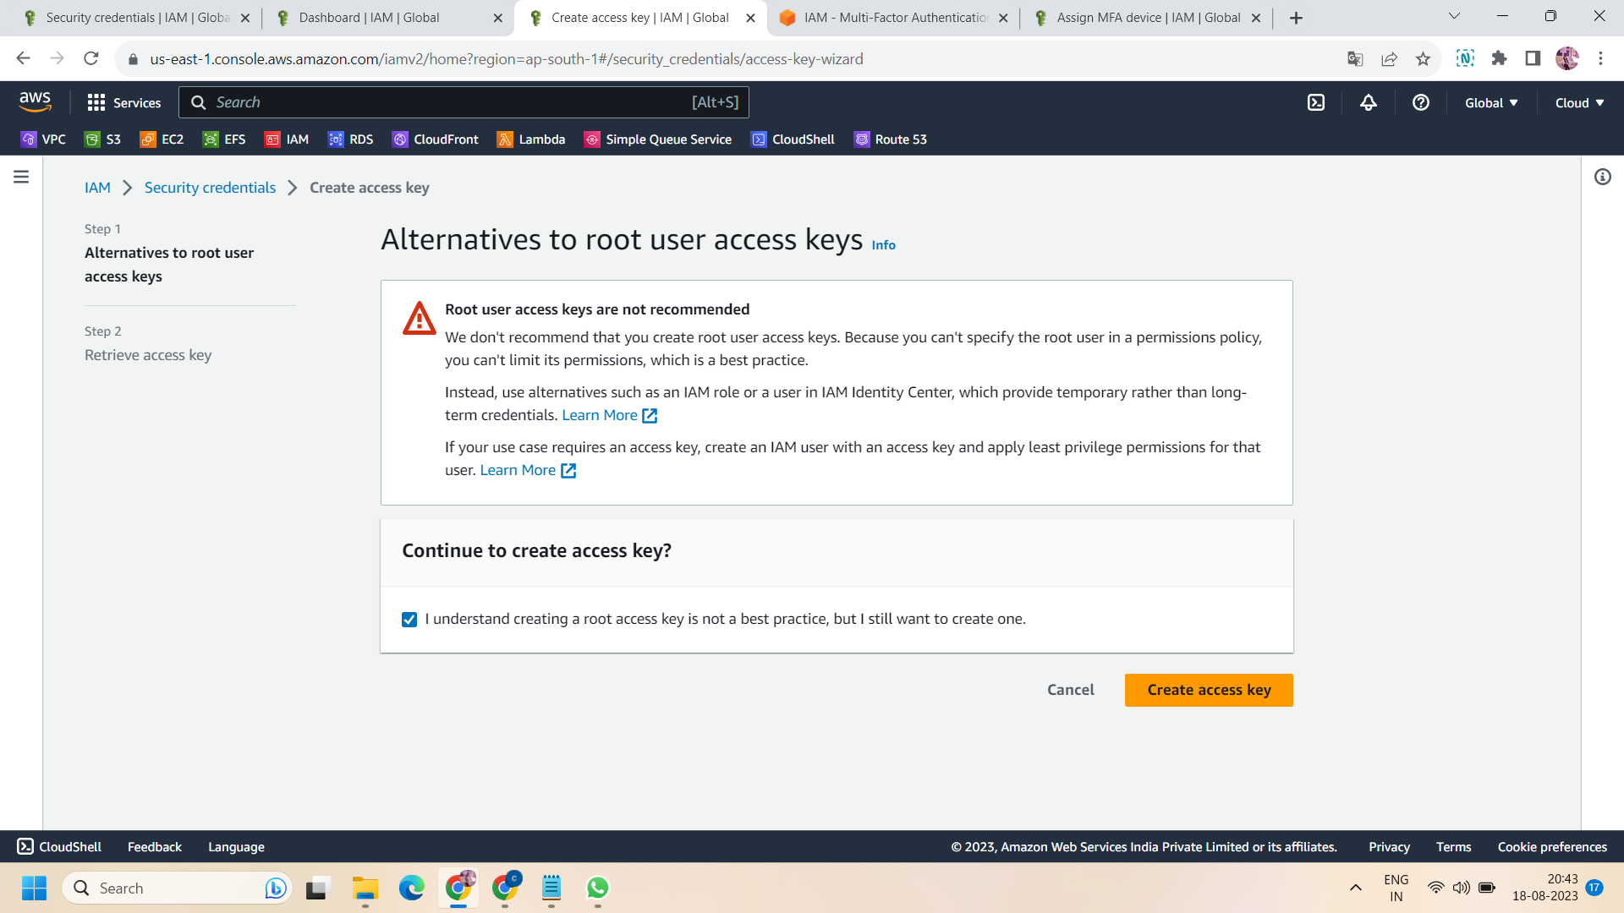

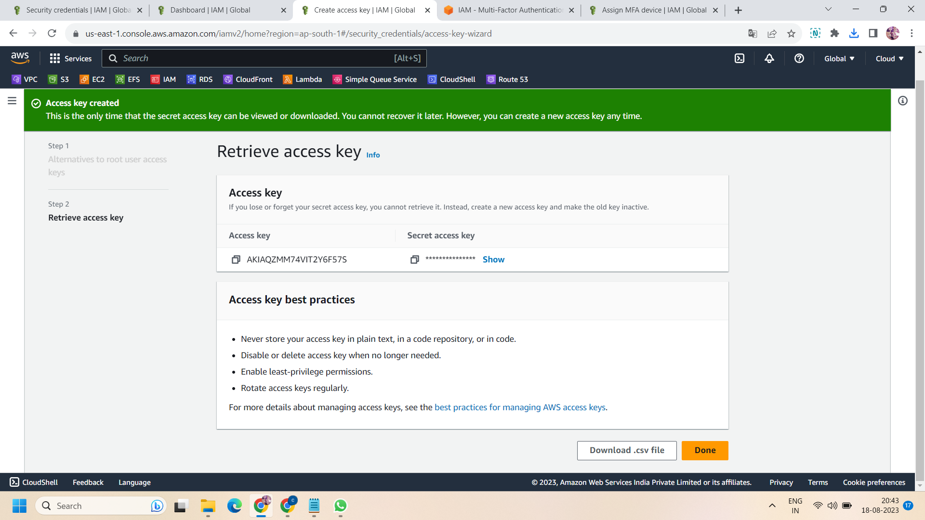

Step 7: after create the access policy ,then go to cloushell or cli and to generate root access apply following command:

# generate root access keys

aws configure --profile root-mfa-delete-demo

And then paste the access key ,secret ID that you saved to during creation of the access key and specify the region of your bucket.

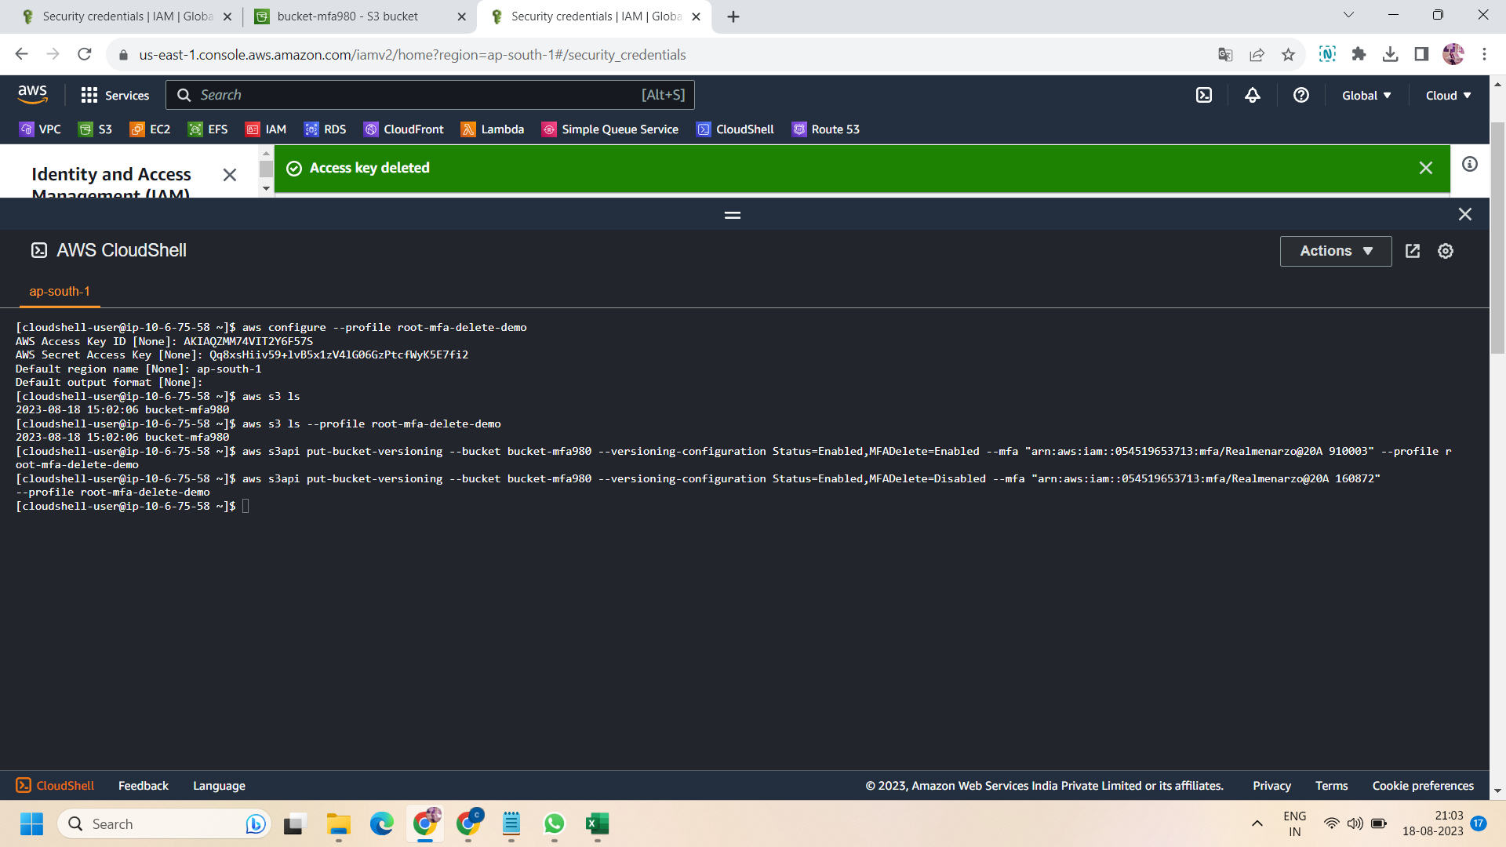

Step 8: to access the s3 bucket :

aws s3 ls --profile root-mfa-delete-demo

Step 9: then to enable the MFA delete ,apply the following command :

# enable mfa delete

aws s3api put-bucket-versioning **BUCKET NAME** --versioning-configuration Status=Enabled,MFADelete=Enabled --mfa "**arn-of-mfa-device** **mfa-code**" --profile root-mfa-delete-demo

Here replace the bucket name with your s3 bucket name

And replace this ‘arn-of-mfa-device’ with ARN of your MFA and ‘mfa-code’ with your mfa code generated through your preferred authenticator app.(google authenticator)

Step 10 : Now ,move to the s3 console and go to bucket versioning,this time you will get that mfa delete is “enabled” now.

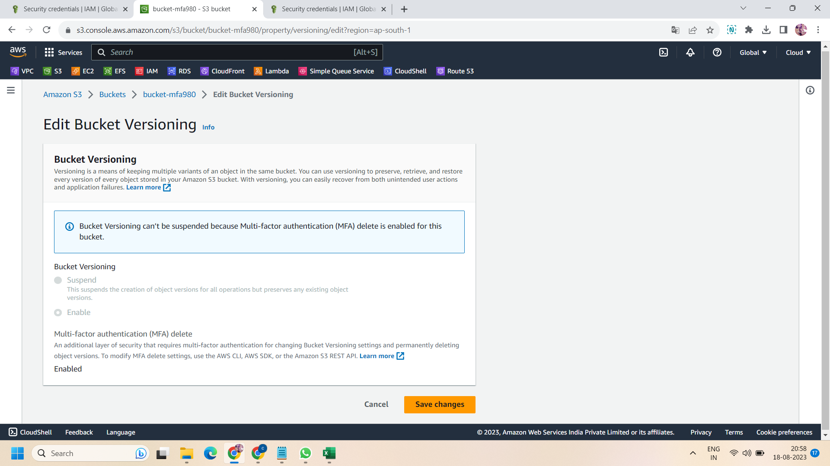

Step 11: now upload an object in the bucket and then try to delete it .it will delete with delete marker .but when you try to delete that delete marker in its object versions then you have not that permission to delete as you already enable “MFA delete” ,so we have to first disable the MFA delete then we can delete the delete marker .

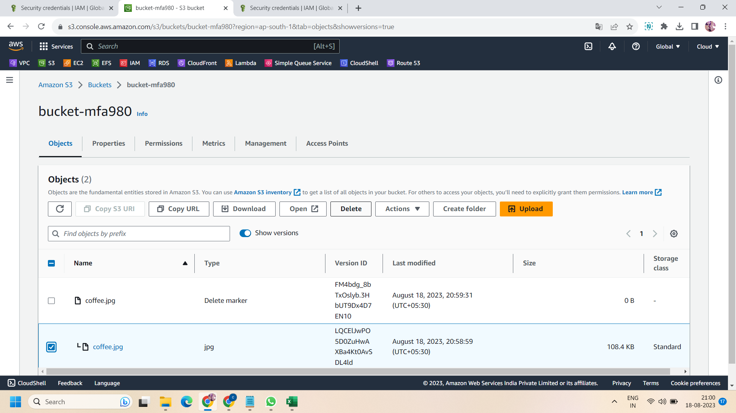

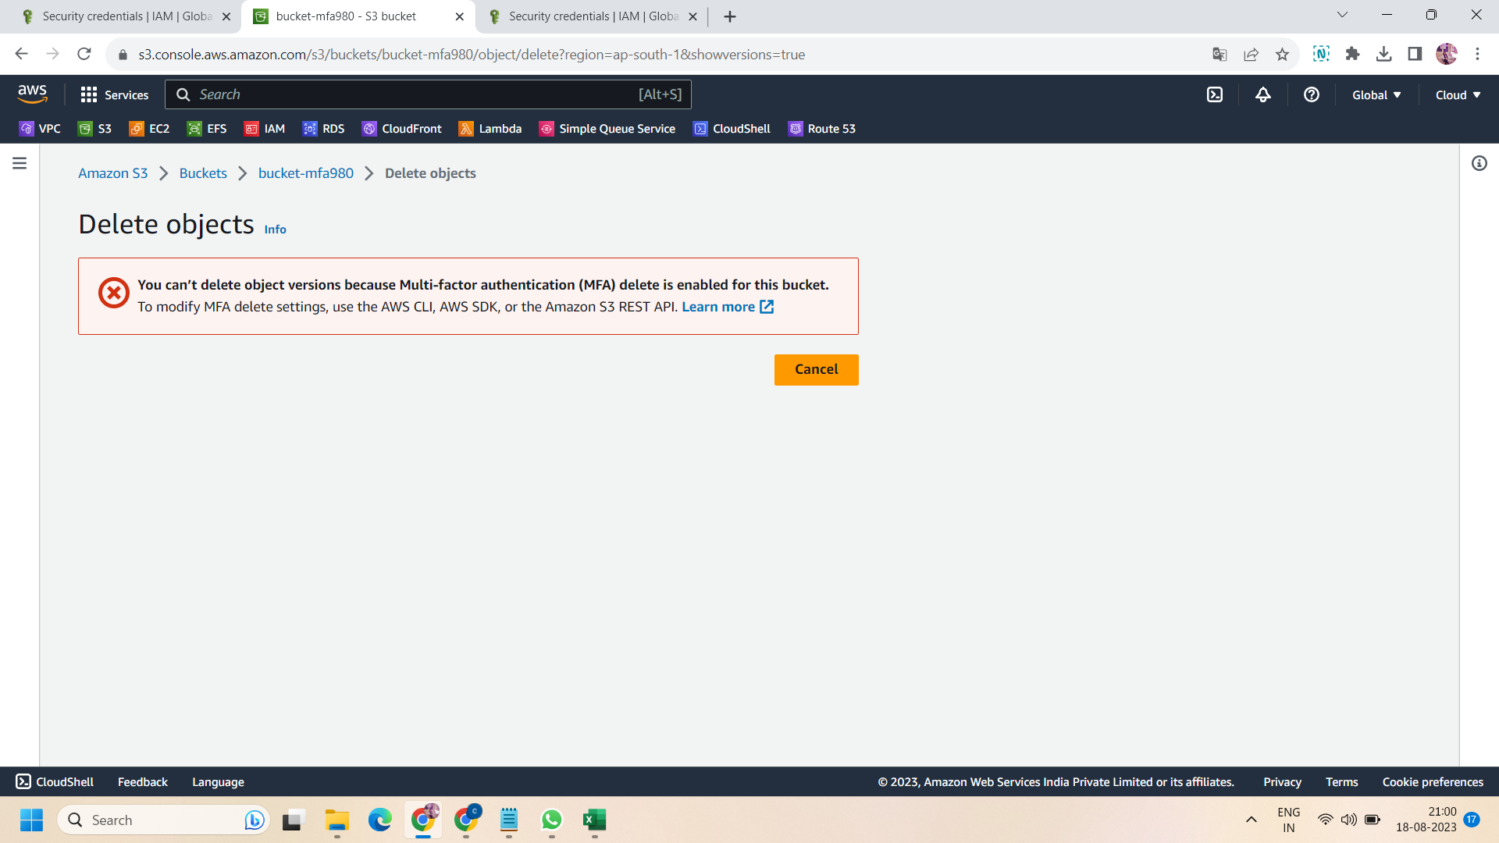

Step 12: to disable the “MFA Delete” ,apply the following on CLI :

aws s3api put-bucket-versioning **BUCKET NAME** --versioning-configuration Status=Enabled,MFADelete=Disabled --mfa "**arn-of-mfa-device** **mfa-code**" --profile root-mfa-delete-demo

Similarly as you do at the time of mfa enable,here also replace the bucket name with your bucket name ,arn of your mfa and mfa code .

Step 13: again move to s3 bucket ,and try to delete the delete marker of your object ,now it will be deleted as you disable the mfa delete settings .That is the way how mfa delete works.

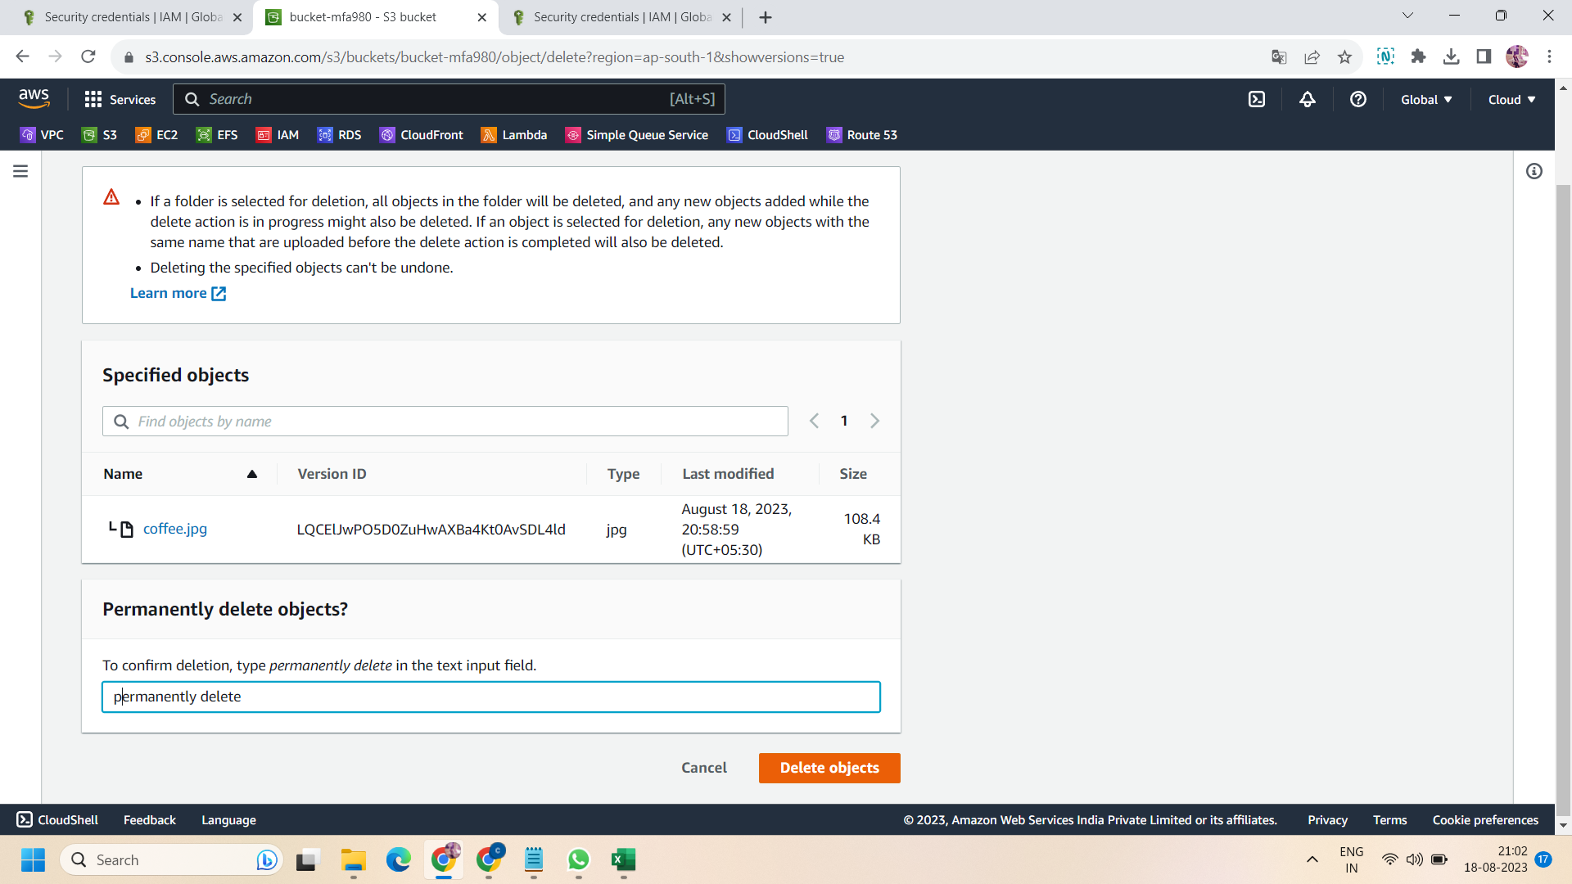

Step 14: before ending the lab,don't forget to delete the access key credentials.

SUCCESSFULLY DONE!!